Descriptive Analysis

Definition
# Source: AI Source: Provided by: [Data Path: Persons Table -> ID Column: 1, Name_En Column: Motasem Essam] -> From: [Chatgpt (GPT‑5 Mini)] on [12/10/2025]
Descriptive analysis is the process of summarizing and describing historical or existing data to understand what has happened.
- It focuses on presenting the data in a meaningful way using statistics, tables, and visualizations.

Key idea:
# Source: AI Source: Provided by: [Data Path: Persons Table -> ID Column: 1, Name_En Column: Motasem Essam] -> From: [Chatgpt (GPT‑5 Mini)] on [12/10/2025]
It’s like taking a snapshot of the data to see patterns, totals, averages, or distributions.

Characteristics of Descriptive Analysis
# Source: AI Source: Provided by: [Data Path: Persons Table -> ID Column: 1, Name_En Column: Motasem Essam] -> From: [Chatgpt (GPT‑5 Mini)] on [12/10/2025]
- Uses summary statistics like mean, median, mode, totals, and percentages
- Often visualized using charts, graphs, and tables
- Helps in understanding trends, patterns, and distributions
- Does not predict the future or explain causes
- Suitable for reporting and dashboards

Example
# Source: AI Source: Provided by: [Data Path: Persons Table -> ID Column: 1, Name_En Column: Motasem Essam] -> From: [Chatgpt (GPT‑5 Mini)] on [12/10/2025]
A sales dataset for a store:

Product | Units Sold | Revenue ($)
Laptop | 50 | 50,000
Phone | 120 | 60,000
Tablet | 30 | 12,000
Descriptive Analysis:
- Total Units Sold: 50 + 120 + 30 = 200
- Total Revenue: $50,000 + $60,000 + $12,000 = $122,000
- Average Revenue per Product: $122,000 ÷ 3 ≈ $40,667

Example Section
# Source: AI Source: Provided by: [Data Path: Persons Table -> ID Column: 1, Name_En Column: Motasem Essam] -> From: [Chatgpt (GPT‑5 Mini)] on [12/10/2025]
A manager wants to understand monthly sales:
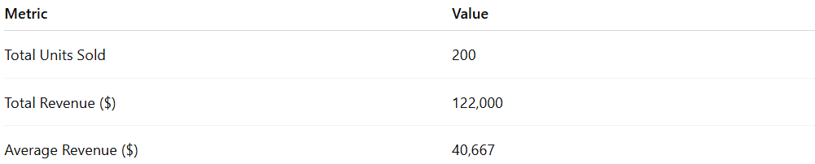
Metric | Value
Total Units Sold | 200
Total Revenue ($) | 122,000
Average Revenue ($) | 40,667
- Descriptive analysis gives a clear summary of sales performance.
- It does not explain why sales are high or low, only shows the numbers.

Advantages
# Source: AI Source: Provided by: [Data Path: Persons Table -> ID Column: 1, Name_En Column: Motasem Essam] -> From: [Chatgpt (GPT‑5 Mini)] on [12/10/2025]
- Provides a clear summary of data
- Easy to understand and communicate
- Helps in identifying patterns or trends
- Forms the foundation for further analysis

Disadvantages
# Source: AI Source: Provided by: [Data Path: Persons Table -> ID Column: 1, Name_En Column: Motasem Essam] -> From: [Chatgpt (GPT‑5 Mini)] on [12/10/2025]
- Does not explain causes or reasons behind trends
- Cannot predict future outcomes
- Limited in providing actionable insights beyond summarizing data
- May oversimplify complex datasets if relying only on averages or totals
- Can be misleading if data is incomplete or biased

